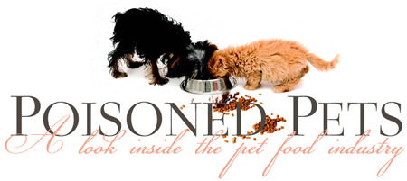

Table. Exemptions & Requirements in Human Food v. Animal Food – A comparison

Who or What Would Be Exempt | Hazard Analysis and Risk Based Preventive Control Requirements | Current Good Manufacturing Practices (CGMP)
“Qualified Facility” as defined by FSMA:  Business with average annual sales of <  $500,000 and at least half the sales to consumers or local retailers or  restaurants (within the same state or  within 275 miles); or  Very small human food business  Option 1: Average annual sales of  < $250,000  Option 2: Average annual sales of  < $500,000  Option 3: Average annual sales of  <$1,000,000  Very small animal food business  Option 1: Total annual sales of  < $500,000  Option 2: Total annual sales of <  $1,000,000  Option 3: Total annual sales of  <$2,500,000 | Exempt in human & animal food  (Exception for annual sales requirement of a human food v. an animal food business) | Same requirements for both human & animal food businesses
Low risk, on farm activities performed by small human food business (< 500 employees)-or-  Low-risk, on-farm activities performed  by a very small human food business  Option 1: very small =  <$250,000  Option 2: very small =  <$500,000  Option 3: very small =  <$1,000,000  Low risk, on farm activities performed  by a small animal food business (< 500 employees): or  Low-risk, on-farm activities performed by  a very small animal food business  Option 1: very small =  <$500,000  Option 2: very small =  <$1,000,000  Option 3: very small =  <$2,500,000 | Exempt in human & animal food  (Exception for annual sales requirement of a human food v. an animal food business) | Same requirements for both human & animal food businesses
Registration for farms; restaurants; other retail food establishments; nonprofit food establishments or fishing vessels | Exempt for human & animal food
Certain low-risk manufacturing/processing activities, packing or holding activities that are conducted by small or very small businesses on farms for specific foods. | Exempt for human & animal food | Must comply
Foods subject to the low-acid canned food (LACF) regulation. | Exempt for human & animal food | Must comply
Activities of a facility that  are subject to Standards for Produce Safety | Exempt in human & animal food | Must comply
Foods subject to HACCP regulations (seafood and juice) | Exempt for human & animal food | Must comply
Dietary supplements | Exempt in human & animal food | Must comply with dietary supplement CGMPs
Activities within the definition of “farm” | Exempt in human & animal food | Exempt in human & animal food
Facilities, such as warehouses, that only store packaged foods that are not exposed to the environment | Exempt in both human & animal food  (Only if refrigeration is not required; if rerigeration is required, the same requirements apply in both human & animal food) | Must comply
Facilities such as grain elevators that store only raw agricultural commodities (other than fruits and vegetables) intended for further distribution or processing | Exempt in human & animal food  (provided they are solely engaged in such storage) | Exempt in human & animal food
Facilities, such as warehouses, that store raw agricultural commodities that are fruits and vegetables intended for further distribution or processing. | Must comply in human food  Exempt in animal food | Exempt in human & animal food

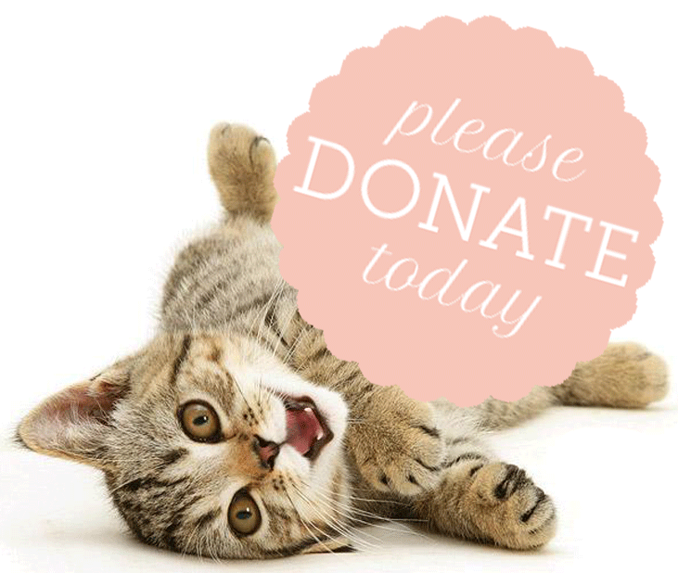

Copyright 2013 Mollie Morrissette | Poisoned Pets

